- Vendor will receive an Email with link.
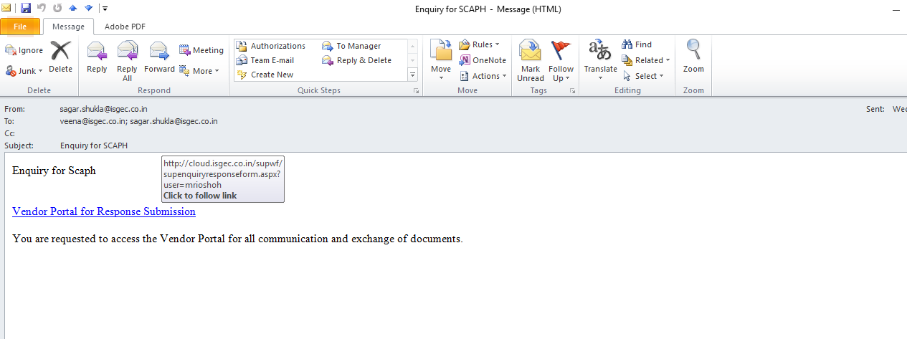
Link Provided to Vendor in E mail

- Vendor to Click on the Link provided, the following screen opens up.
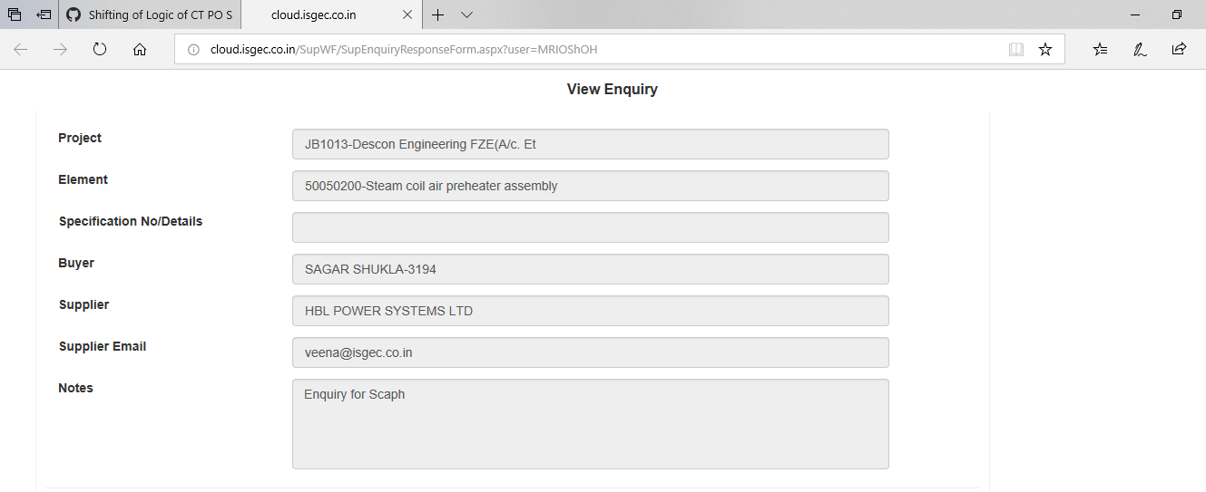
This Screen Open up

- Vendor to download the attachment send(if applicable)
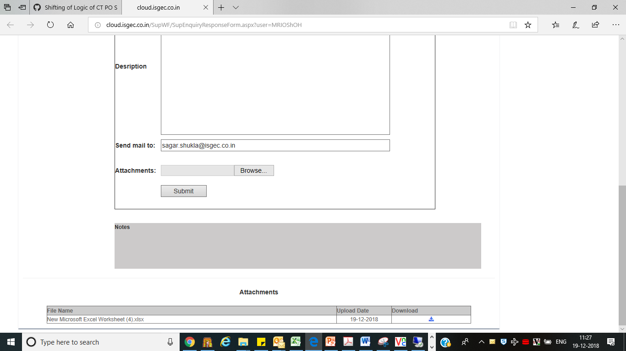
Download attachment

- If Any Clarification is required by Vendor he can use the Notes session as well as attach any documents (if required), then click on Submit Button.
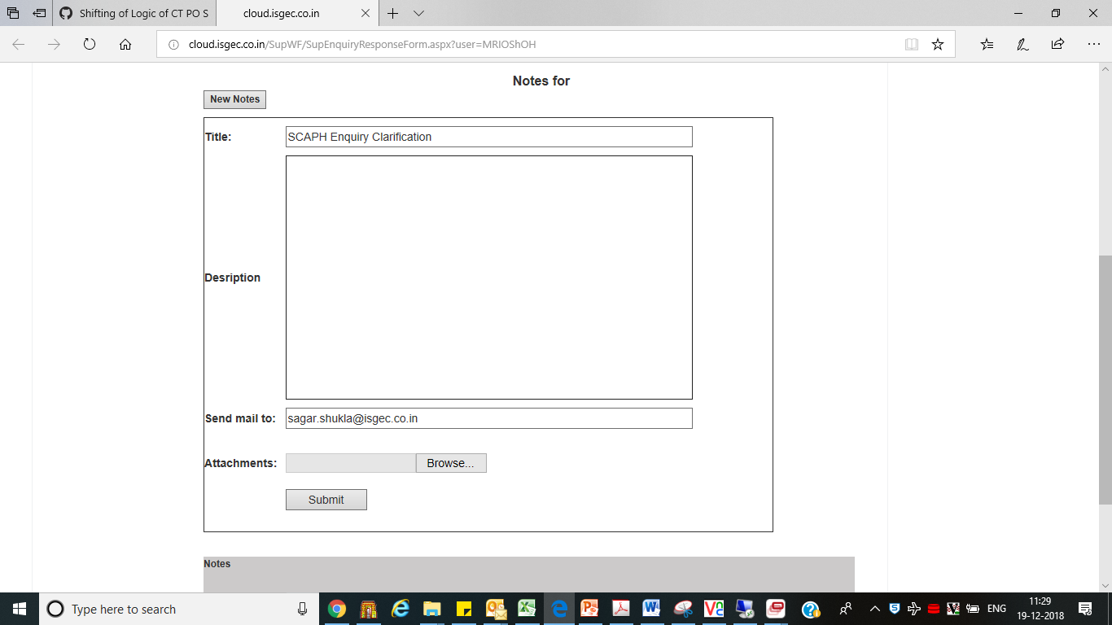
Submit
Upload Attachment
Notes For Clarification

- In the screen that appears select OK.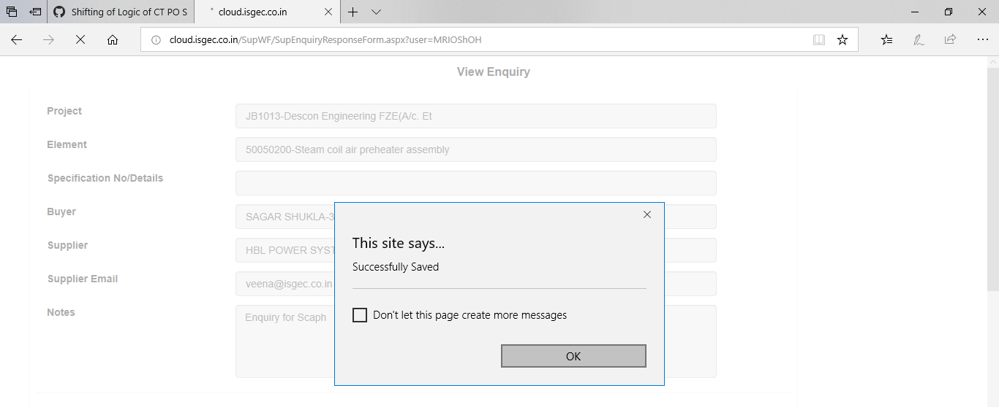
Select OK

- This will appear as Notes as shown in vendor session and an Email Alert is send to Buyer.
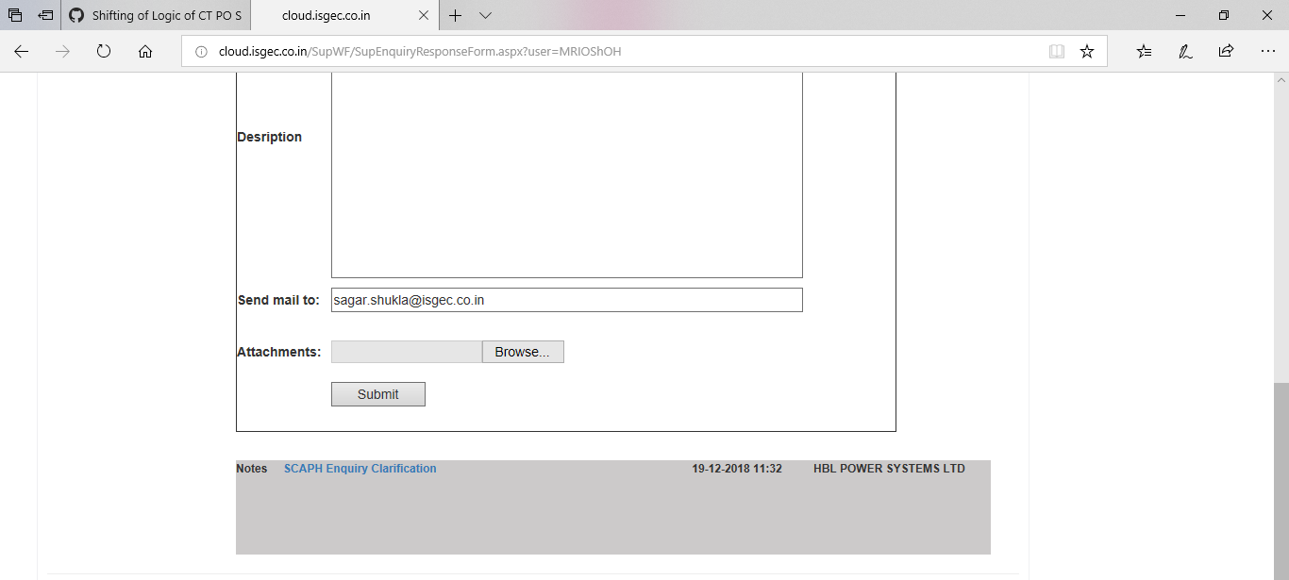
Note Uploaded

